ALL WALES ASSESSMENT OF NEED
FOR ADOPTION SUPPORT SERVICES

Region:

This document should be used when completing adoption support assessments at all stages apart from the 1st adoption support plan. The 1st adoption support plan will be informed by the child’s CAR/B, the prospective adoptive parent’s PAR and the matching documents.
Information gathered in this document, for all subsequent assessments will be used to inform, develop, and update the All Wales Adoption Support Plan.
The plan may be used in conjunction with a Part 4 Social Services and Well-being (Wales) Act 2014 care and support plan.
Name of child (birth or adopted name
as appropriate):
Date of birth:
Name of adoptive family:
Placing authority:
Resident authority (if different):
VAA (if involved):
Date of placement:
Date of adoption order:

Referral Information
Date of current Referral:
Name of person requesting an assessment:
Date of last adoption support plan or review:
Name of adoption support social worker undertaking assessment:

All rights reserved. This document may not be reproduced without the permission of the National Adoption Service for Wales.
GP Name
Are there any known health issues?
Have they seen their GP re current concerns?

Name of nursery/ School/ college:
School Year:
Is educational psychology involved?

Other Agencies Currently Involved: (including specialist services)
Name of Agency | Worker Responsible | Contact Details | Reason for Involvement

Family Composition/ Parental Responsibility/ Significant Others
Name | Relationship | Parental Responsibility | Address

Support Network
Name | Relationship | Type of support offered/available

Previous support offered/received and by whom? (Please also undertake a system check)
Date | Reason for referral | Agency/worker providing | Outcome

Previous support plan (Please also undertake a system check)
Date | Identified Need | Agency/worker providing | Outcome

Reason for current Referral

Current Circumstances (family dynamics, who is in the house, employment, activities etc.)
In addition, you may also want to ask parents:
- What does your child enjoy?
- What are they good at?
- What do other people say they like about your child?
- What does your child struggle with?
- When have things been better/worse?
- What are your concerns?

Background Information Including circumstances that led to the child being placed for adoption, transition to the adoptive family, life in the adoptive family, adaptation to parenthood, traumatic events in family life…
Please add any updated relevant details and date of update
Child’s knowledge of adoption. A brief update on information shared with the child and their understanding of this. What Life Journey materials do they have and what access have they had to these?
Are contact arrangements in place?
- With whom
- Type of contact (direct / remote / indirect)
- Has support been provided in previous support plans?

Assessment:
Gather and record all relevant information. Give consideration to the Child’s Developmental Needs, Parenting Capacity and Family and Environmental Factors as appropriate in line with
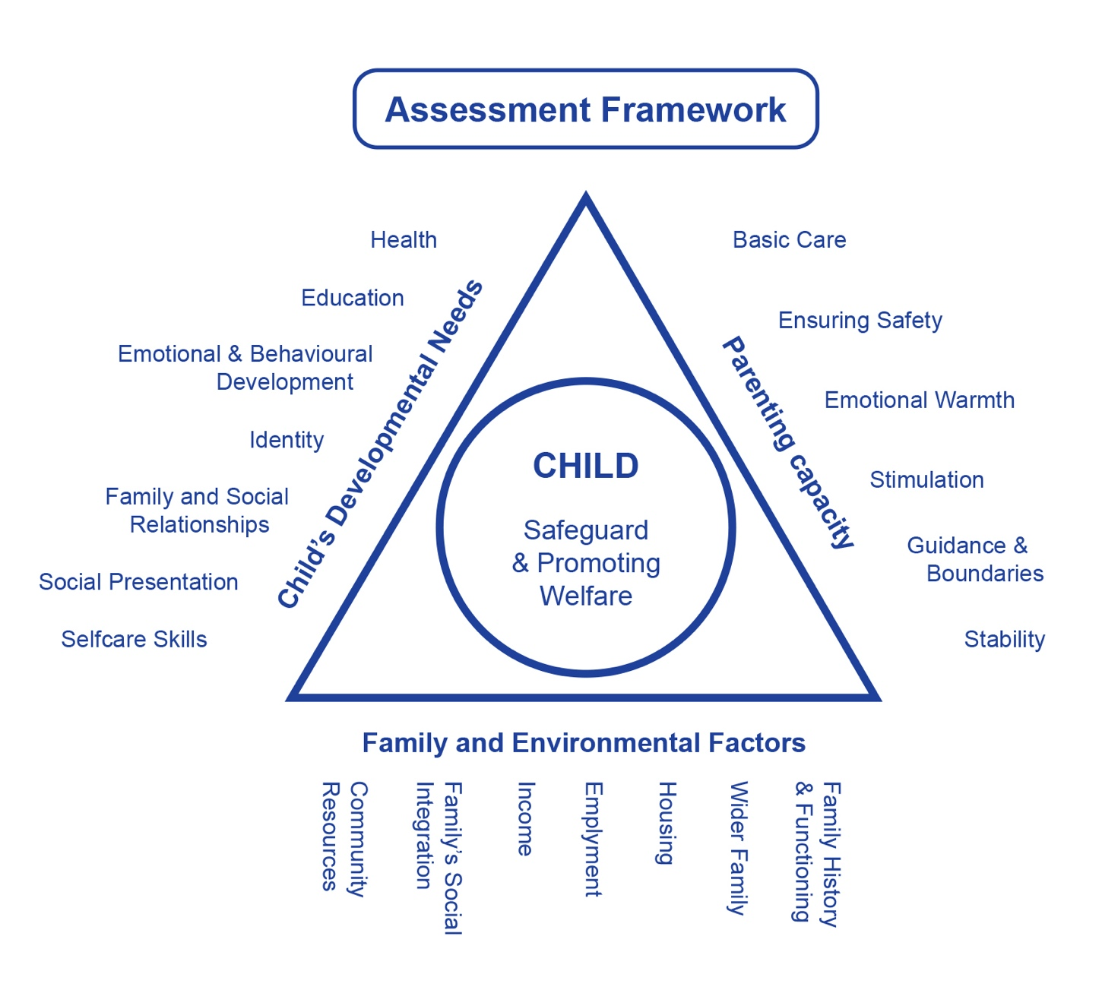
Source: Working Together to Safeguard Children

- Child / Young Persons Developmental Needs
Also state if there are any special needs of the adopted child arising from:
- Being looked after by a local authority
- The child having been habitually resident outside of the UK
- The adoptive parent is a relative of the child
- A trauma informed approach to gathering and analysing information should be taken

Health
Includes growth and development as well as physical and mental wellbeing, the impact of any genetic factors and any impairment caused by pre-birth trauma e.g. FASD.

Education
Covers all areas of a child's cognitive development and progress. It should include information from the child’s parents, school / nursery, educational psychologist (if appropriate) about the child’s progress and services provided and include relevant details about whether the educational provision employs a trauma informed approach to working with the child.

Emotional and behavioural development
Includes the impact of early trauma on the child and the quality and nature of their early attachments with birth parents; the development of, and quality and nature of, their attachments with their adoptive family; any continuing needs arising from early trauma.

Identity
How well does the child understand their narrative and why they have been adopted; what life journey work has been completed (see above); do the adoptive parents practise open communicativeness in their everyday life with the child. How have these contributed and supported the child’s sense of self, self-esteem and confidence.
Has any particular circumstance or experience relating to their ethnicity, religion, age, gender, sexual orientation or disability been considered and taken into account.

Family and social relationships
Development of empathy and the capacity to place self in someone else's shoes. Includes a stable and affectionate relationship with parents; positive relationships with siblings, including separated siblings; increasing importance of age appropriate friendships with peers and the challenges inherent in this; relationships with other significant persons in the child's life and response of family to these relationships.

Social presentation
How is the child’s understanding of the way in which appearance and behaviour are perceived by the outside world; includes appropriateness of dress; cleanliness and personal hygiene; how are they supported with any challenges and whether any further support is needed.

Self-care skills
How is the child developing age appropriate skills for independence; includes early practical skills of dressing and feeding; opportunities to gain confidence and practical skills to undertake activities away from the family; independent living skills as young people. How do the parents encourage problem solving and support any challenges? Are there any additional needs or circumstances identified that need particular attention?

- Parenting Capacity
Include any challenges in the parents’ current circumstances

Basic care
Providing for the child's physical and emotional needs; includes appropriate medical and dental care, and care arising from any additional needs.

Ensuring safety
Providing a safe base to support and encourage appropriate and safe exploration, and a safe haven to provide age appropriate comfort and support. Ability to protect the child from harm and to recognise any additional needs arising from early trauma.

Emotional warmth
Ensuring the child's emotional needs are met giving the child a sense of being specially valued and a positive sense of their own identity as an adopted person.

Stimulation
How is the child’s learning and development encouraged and supported? Are the adoptive parents aware of the importance of play and playfulness in their relationship with the child; do they need any additional support in maximising their capacity to understand and provide for the child’s needs so that the child can reach their potential?

Guidance and boundaries
Have the adoptive parents established a secure base for the child; are they able to provide reparative parenting that helps a child recover from early trauma and do they need any additional support; do they need support to provide age appropriate boundaries as the child gets older?

Stability
Recognising the importance of a stable and secure family environment to enable a child to develop and maintain a secure attachment to their adoptive parents and siblings; consistent and empathic support to keep in touch with important people. Are there any changes that challenge or undermine this stability at the moment; what support can help with this?

- Family and Environmental Factors

Family History and Functioning
What have been the challenges and successes this family have experienced; how have these affected them; are there any support needs arising from family structure and functioning?

Wider Family
Who are the wider family members that provide love and support to the family; has their ability to provide supported been compromised in any way and what would help this?

Housing
Is there any new information about the family’s housing situation that is relevant and impacts upon day to day functioning?

Employment & Income
Are there any issues relating to employment and income that are affecting the family at the moment?

Family’s Social Integration
How well have the family integrated into their community and how well do they understand the benefits to the child. Are there any issues arising from the child’s early trauma that may be affecting integration and what support could assist with this?

Community Resources
Neighbourhood and surroundings and how adoptive parents access these for the benefit of the child. Are there any specific resources needed relating to any additional needs within the family, including accessibility?

Does this Assessment relate to a particular adoption support service? | Yes |  | No
If yes, please specify service requested or how the need for a particular service has been determined (see regulation 7(2) Adoption Support Services (Local Authorities) (Wales) Regulations 2005 which gives the LA the power to limit an assessment to the need for a particular service where it is requested by persons set out in Regulation 7(1), and the local authority considers the limited assessment adequate)

What outcomes for the child are we looking to achieve?: What outcomes do the child/family wish to achieve? What matters to them? Where are they now? Where do they want to be? What will that look like? How will they get there?
Parent/s

Child

Conclusion and Analysis
Analyse the information as the basis for planning support. Identify strengths as well as challenges.
Strengths
Challenges including any risks to the child identified

Identified Needs  A clear understanding of the needs of the adopted child and adoptive family and how these may be met/what is required to meet these needs? Include how any challenges / risks identified to achieving outcomes may be overcome | Proposed Actions / Services to be provided  Include the basis for decision making. How will the desired personal outcomes be achieved?  These details will need to be added to the updated Adoption Support Plan with date of update

Child/Young Person’s Views/Comments The child / young person’s views should always be sought if they are of an age and understanding to express their views. If they are not of such an age and understanding, then their wishes and feelings should always be considered.
Parent’s Views/Comments

Signature of Social Worker Completing Assessment |  | Date
Signature of Manager |  | Date
Manager Comments
Signature of Parent / Carer |  | Date
Signature of Child / Young Person |  | Date

Adoptive parent(s) provided with a copy of the assessment (a period of 28 days is given for the purposes of making representations regarding the proposed services) | Date Sent

